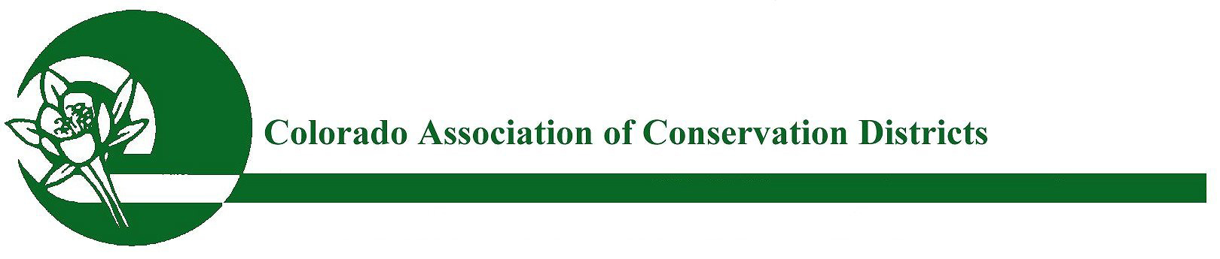
Mailing address: P.O. Box 1175, Lamar, CO 81052

CACD 2021 Conservationist of the Year ~ Excellence Award
Farmer, Rancher, Small Acreage, Forestry/Mining Landowner

PURPOSE:
The purpose of this award is to recognize an outstanding individual that implements innovative conservation and agricultural practices that have proven successful. This Conservationist reaches out to a variety of audiences, engages new partnerships, and spreads the conservation message. The Conservationist(s) honored will serve as models of excellence for other Conservationists.

ELIGIBILITY:
All Districts are eligible to participate in this program. The nominee(s) voted through by the watershed to CACD are eligible for receiving the state award unless the nominee(s) have won the “CACD Conservationist of the Year” award in the past three years.

APPLICATION & NOMINATION PROCESS:
To nominate your Farmer, Rancher, Small Acreage, and Forestry/Mining landowner, please complete the attached nomination form & submit to your watershed for voting. Please check with your watershed for their deadline date. Nomination forms to the watersheds must be in WORD DOC and should include a description (1000 words or less) of the nominee’s success in implementing conservation practices (traditional and non-traditional) on their own operation(s) and in community outreach and education (e.g., tours, school field days, etc.). During time in operation, this nominee has utilized land stewardship practices and sound conservation methods. Please include the size of the nominee’s operation and any letters of recommendation from partner agencies and/or agricultural affiliates. Please also submit up to five (5) pictures; in addition to a brief paragraph for promotional purposes.

Once the winner(s) have been chosen by the watershed, the nominating district will need to submit this word doc nomination form, along with the same supporting documents & pictures to CACD no later than October 1st, 2021. Once a winner is chosen by CACD (by Oct 20th); the nominating district will be asked to summarize this word doc form down to 500 words or less and then submit back to CACD no later than October 26th, 2021.

JUDGING & AWARDS:
Entries will be judged by the CACD Awards Committee. One award will be given each year in the Conservationist of the Year categories of: Farmer, Rancher, Forestry/Mining, and Small Acreage (less than 100 acres) Landowner. The winners will score the highest and will meet the minimum criteria of excellence levels. The winning Farmer, Rancher, Small Acreage & Forestry/Mining Conservationist will receive a plaque and be recognized at the CACD Annual Meeting, in November 2021. *Farmer and Rancher of the Year will also be recognized at the National Western Stock Show in January 2022.

REMINDER: SUBMISSION DEADLINE FOR STATE JUDGING:
Entries chosen from watersheds must be submitted to CACD no later than October 1st, 2021.
Submit nominations to: CACD ED, Bobbi Ketels – bobbi@coloradoacd.org

2021 CONSERVATIONIST OF THE YEAR NOMINATION FORM

Conservation District:
District Manager:
Address:
City/Town/State/Zip:
Telephone:
Email:
Website:
Endorsement: (CD Board President)
Date:
******************************************************************************************
Please Mark One with an X:
Farmer [ ] Rancher [ ] Small Acreage [ ] Forestry/Mining [ ]
COY NOMINEE NAME(S):
COY OPERATION NAME (if applicable):
Phone:
Email:
Website:
Address:
City/Town/State/Zip:

Nominee’s information may be typed here as a continuation of this word doc or
attached in a separate word doc form.

Supporting letters of recommendation may be in PDF format.
Pictures submitted must be in JPG format:

Submit watershed nominations to CACD ED, Bobbi Ketels – bobbi@coloradoacd.org

***

